 | SALES ENQUIRY CHECK LIST OR QUESTIONNARIE
1 | Name of Site and location
2 | Arch. details
3 | Business Partner details
4.Op1. | Floor Mount RR | 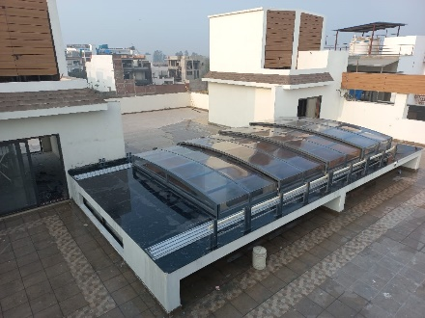
Op2 | Both side wall mount RR | 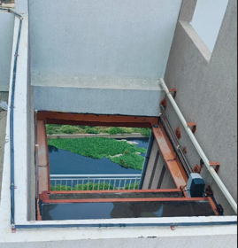
Op3 | Balcony Enclosure (“L” shape) | 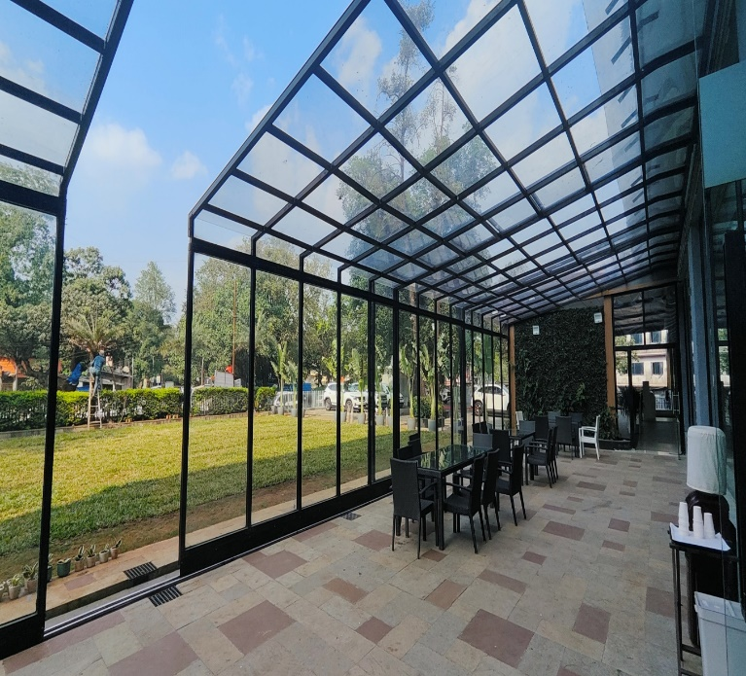
Op4 | “C” shape Enclosure | 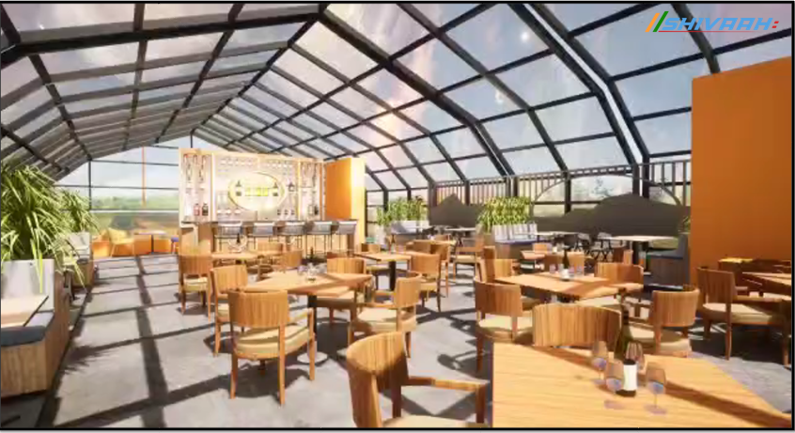
Op5 | Dome | 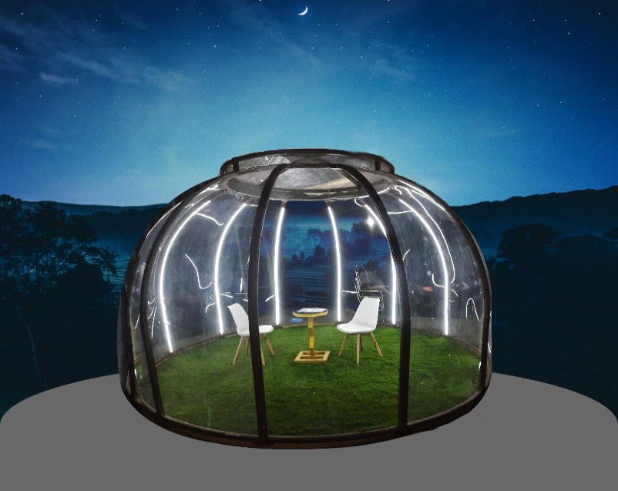
5. | Type of Movement | Telescopic Sliding / Single Panel
6. | Dimension of Cutout of Roof/Enclosure -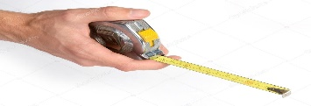 |  |  |  | Inner Dim’s |  | Outer Dim’s
6. |  | Length
 |  | Width
 |  | Height
7. | Type of Operation | Manual | Motorised with Remote |  |  |  |  |  | Control Switch
8. | Enclosure Opening Option | Partial Opening |  | Full Opening  Available Stacking Space |  |  |  | Centre  Opening |  |  | Side  Opening
9. | Polycarbonate | Clear Compact |  |  |  | Compact Embossed |  |  |  | Bronze Clear/Embossed
9. | Polycarbonate | 100% Clear
10 | Type of Glass
11 | Site Photograph/CAD file
12 | Gutter Requirement
13 | Material lifting Floor
14 | Size of Material Lift (L X W X HT)
15 | Civil Leakage points

Note: -
- Require approx. 120 mm space for each track
- Motor Spacing with Bus bar – 350 mm to 450 mm + space require for Track mounting
- Retractable roof/Pool Enclosure maximum span– Width 10000mm
- L shape Enclosure - Maximum span – Width 7000mm
- C shape Enclosure - Maximum span – Width 10000mm
- Dome - Maximum span – Dimeter 8000mm

